Project Design Phase-II
Technology Stack (Architecture & Stack)

Date | 25 September 2026
Team ID | SWTID-2026-8948
Project Name | AI FAQ Assistant
Maximum Marks | 4 Marks

Technical Architecture
The Deliverable shall include the architectural diagram as below and the information as per Table 1 & Table 2.
Example: AI FAQ Assistant – Technical Architecture
The AI FAQ Assistant follows a layered backend architecture that integrates user requests, authentication, business logic, database management, and AI-powered services. The architecture provides a structured flow for creating, managing, searching, and generating FAQs.
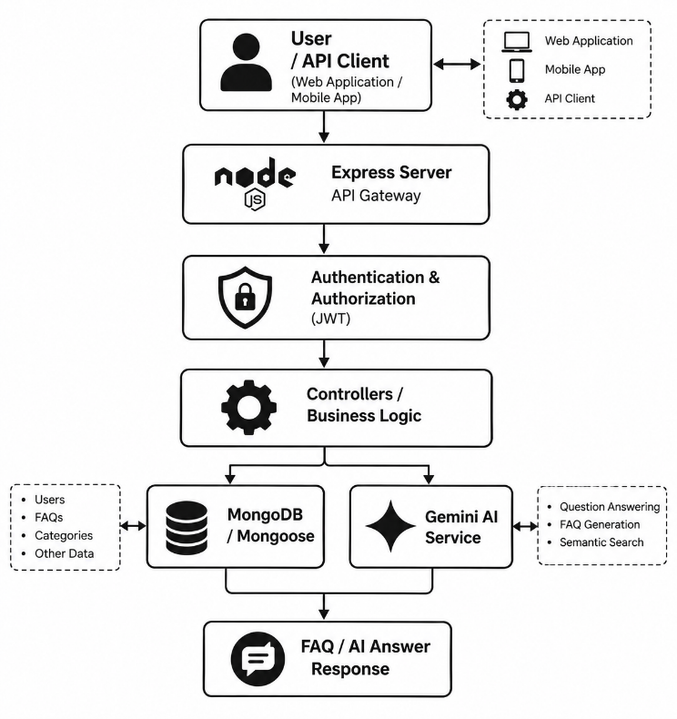

Architectural Components

Component | Description
User / API Client | Sends registration, login, FAQ, search, and question-answer requests to the system.
Express Server | Acts as the main API gateway and handles incoming HTTP requests and responses.
Authentication Layer | Validates JWT tokens and controls access to protected resources.
Controller / Business Logic | Processes user requests and applies the required application logic.
MongoDB / Mongoose | Stores and manages user information, FAQ records, categories, and related data.
Gemini AI Service | Processes user questions and generates AI-based answers and FAQ content.
Response Layer | Returns the requested FAQ information or AI-generated response to the user.

Architecture Interaction

Step | Process | Description
1 | Request | User sends a request through the API client.
2 | API Processing | Express server receives and routes the request to the appropriate endpoint.
3 | Authentication | JWT token is validated for protected operations.
4 | Business Processing | Controller processes the request according to the required operation.
5 | Database Operation | Mongoose communicates with MongoDB to store or retrieve FAQ and user data.
6 | AI Processing | Questions requiring AI assistance are sent to the Gemini AI service.
7 | Response | The processed FAQ information or AI-generated answer is returned to the user.

